**Tabela 1**. Total da Variância Explicada

|  |  |  |  |  |  |  |  |  |  |
| --- | --- | --- | --- | --- | --- | --- | --- | --- | --- |
| Component | Initial Eigenvalues | | | Extraction Sums of Squared Loadings | | | Rotation Sums of Squared Loadings | | |
| Total | % of Variance | Cumulative % | Total | % of Variance | Cumulative % | Total | % of Variance | Cumulative % |
| 1 | 7,375 | 30,728 | 30,728 | 7,375 | 30,728 | 30,728 | 4,109 | 17,119 | 17,119 |
| 2 | 1,948 | 8,117 | 38,845 | 1,948 | 8,117 | 38,845 | 3,601 | 15,003 | 32,123 |
| 3 | 1,594 | 6,640 | 45,485 | 1,594 | 6,640 | 45,485 | 3,093 | 12,888 | 45,011 |
| 4 | 1,081 | 4,506 | 49,991 | 1,081 | 4,506 | 49,991 | 1,195 | 4,980 | 49,991 |
| 5 | …… | ……. | …….. |  |  |  |  |  |  |
| 23 | ,384 | 1,598 | 98,551 |  |  |  |  |  |  |
| 24 | ,348 | 1,449 | 100,000 |  |  |  |  |  |  |
| Extraction Method: Principal Component Analysis. | | | | | | | | | |

**Tabela 2.** Consistência interna – Alfa de Cronbach

|  |  |  |
| --- | --- | --- |
| Constructo | Alpha de Cronbach | Nº de itens |
| ***Integração e Satisfação de Necessidades*** | 0,728 | 6 |
| ***Estatuto de Membro*** | 0,664 | 6 |
| ***Influencia*** | 0,690 | 6 |
| ***Relações Emocionais Partilhadas*** | 0,765 | 6 |

**Tabela 3**. Índices de ajustamento

|  |  |  |  |  |  |
| --- | --- | --- | --- | --- | --- |
| $$χ^{2}$$ | $$χ^{2}/df$$ | $$CFI$$ | $$PCFI$$ | $$GFI$$ | $$PGFI$$ |
| $$740,993$$ | $$3,650$$ | $$0,435$$ | 0,382 | $$0,917$$ | $$0,736$$ |

##### **Tabela 4:** *Regression Weights: (Group number 1 - Default model)*

|  |  |  | Estimate | S.E. | C.R. | P |
| --- | --- | --- | --- | --- | --- | --- |
| Q4 | 🡨 | Reinforcement_of_needs | ,993 | ,100 | 9,948 | *** |
| Q5 | 🡨 | Reinforcement_of_needs | 1,438 | ,146 | 9,820 | *** |
| Q7 | 🡨 | Membership | 1,000 |  |  |  |
| Q13 | 🡨 | Influence | 1,000 |  |  |  |
| Q11 | 🡨 | Membership | ,909 | ,118 | 7,712 | *** |
| Q9 | 🡨 | Membership | ,894 | ,123 | 7,251 | *** |
| Q8 | 🡨 | Membership | ,900 | ,115 | 7,816 | *** |
| Q1 | 🡨 | Reinforcement_of_needs | 1,000 |  |  |  |
| Q2 | 🡨 | Reinforcement_of_needs | 1,216 | ,127 | 9,592 | *** |
| Q3 | 🡨 | Reinforcement_of_needs | ,955 | ,097 | 9,807 | *** |
| Q21 | 🡨 | Shared_emotional_connection | 1,070 | ,070 | 15,380 | *** |
| Q22 | 🡨 | Shared_emotional_connection | 1,154 | ,135 | 8,576 | *** |
| Q23 | 🡨 | Shared_emotional_connection | ,993 | ,091 | 10,879 | *** |
| Q24 | 🡨 | Shared_emotional_connection | 1,204 | ,135 | 8,907 | *** |
| Q19 | 🡨 | Shared_emotional_connection | 1,000 |  |  |  |
| Q20 | 🡨 | Shared_emotional_connection | 1,209 | ,128 | 9,417 | *** |
| Q18 | 🡨 | Influence | 1,103 | ,123 | 8,964 | *** |
| Q12 | 🡨 | Membership | ,854 | ,105 | 8,135 | *** |
| Q6 | 🡨 | Reinforcement_of_needs | 1,173 | ,123 | 9,533 | *** |
| Q15 | 🡨 | Influence | 1,052 | ,112 | 9,421 | *** |
| Q16 | 🡨 | Influence | 1,035 | ,135 | 7,696 | *** |
| Q17 | 🡨 | Influence | 1,010 | ,112 | 9,030 | *** |

**Tabela 5.** Covariancias: (Grupo n.º1 – Modelo por defeito)

|  |  |  | Estimate | S.E. | C.R. | P |
| --- | --- | --- | --- | --- | --- | --- |
| Reinforcement_of_needs | ↔ | Membership | ,145 | ,015 | 9,952 | *** |
| Influence | ↔ | Shared_emotional_connection | ,148 | ,023 | 6,496 | *** |
| Membership | ↔ | Shared_emotional_connection | ,160 | ,017 | 9,432 | *** |
| Reinforcement_of_needs | ↔ | Shared_emotional_connection | ,113 | ,016 | 7,132 | *** |
| Reinforcement_of_needs | ↔ | Influence | ,121 | ,017 | 7,246 | *** |
| Membership | ↔ | Influence | ,163 | ,018 | 8,945 | *** |

**Tabela 6**. Índices de ajustamento do Modelo de 2ª ordem

|  |  |  |  |  |  |
| --- | --- | --- | --- | --- | --- |
| $$χ^{2}$$ | $$χ^{2}/df$$ | $$CFI$$ | $$PCFI$$ | $$GFI$$ | $$PGFI$$ |
| $$757,722$$ | $$3,696$$ | $$0,420$$ | 0,372 | $$0,915$$ | $$0,741$$ |

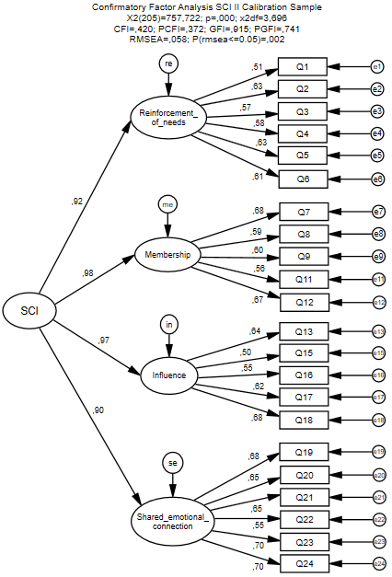

**Figura 1**. Modelo de 2ª ordem de SCI 2